


MANAGEMENT INFORMATION SYSTEM
SBS – MBA / MSC
Assignment – Kuwait 2018

STUDENT ID

UNIT TITLE |  | UNIT CODE

Name (in Full) ____________________________________________________________

GENERAL INSTRUCTIONS

- All assignments are to be submitted on 3rd January 2019
to examinationboard@atmsedu.org and cc to afatima@atmsedu.org.
- Hardcopy submissions to be done on 4th January 2019
- If assignment is not submitted on date, will follow with penalty of 10% deduction of marks for every day.
- Similarity between students work is strictly not accepted, any student found with similar work will be graded Zero and fail for the course. However, Plagiarism is an academic offence and will not be tolerated under SBS
- Assignment once submitted to exam board is final for marking.

PRESENTATION OF ASSIGNMENT

- You should include a title page and list of contents.
- Use headings and sub-headings to organize your report and include supporting material in the document file.
- Number all pages sequentially.
- Any published material you refer to should be properly referenced and included in a reference list at the end of your assignment (see Plagiarism notice overleaf).

Total Marks ________ / 90

PLAGIARISM

Plagiarism is a form of cheating, by representing someone else's work as your own or using someone else's work (another student or author) without acknowledging it with a reference. This is a serious breach of the Academic Regulations and will be dealt with accordingly. Students found to have plagiarised can be excluded from the program.

Plagiarism occurs whenever you do any of the following things without acknowledging the original source:

- Copy information from any source (including the study guide, books, newspapers, the internet)
- Use another person's concepts or ideas
- Summarise or paraphrase another person's work.

How do I avoid plagiarism?

To ensure you are not plagiarising, you must acknowledge with a reference whenever you:

- use another person's ideas, opinions or theory
- include any statistics, graphs or images that have been compiled or created by another person or organization
- Paraphrase another's written or spoken word.

What are the penalties?

The penalties for plagiarism are:

- Deduction of marks,
- A mark of zero for the assignment or the unit, or
- Exclusion from the program.

Plagiarism is dealt with on a case-by-case basis and the penalties will reflect the seriousness of the breach.

Please note: claiming that you were not aware of need to reference is no excuse.

Part A:
Short Answer Questions.
Answer ALL questions from this section - Some questions contain sub questions. Total mark for this section is 60.

QUESTION 1 (10 Marks- 5 each)- This question contains two sub questions a and b.
- Analyse the ‘Voyage’ related illustration below. What type of IS is represented by this illustration? Why? At what organizational level is this IS used?

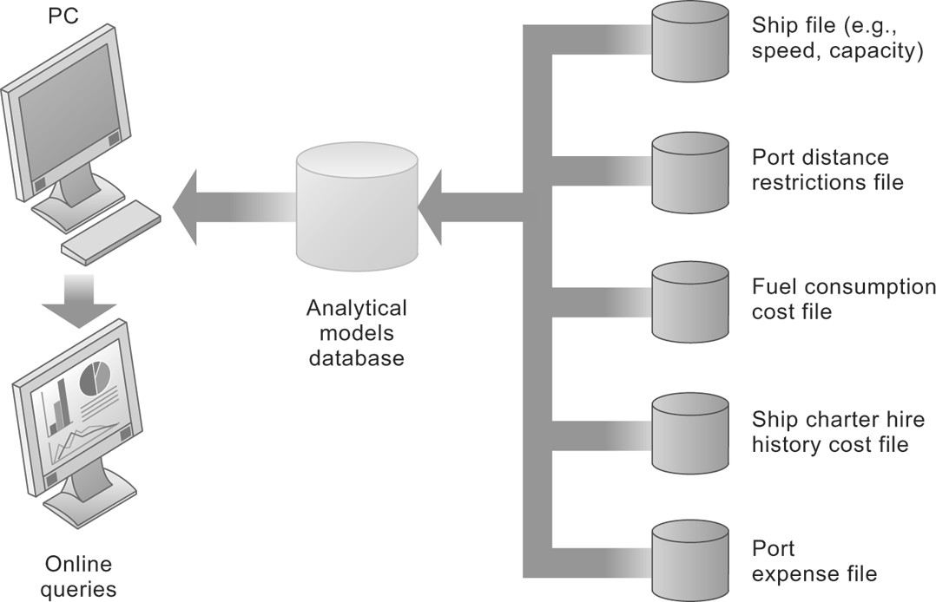

b. Analyse the relationships represented by the illustration below and determine whether the statement/s represented in the table below are true account of such relationships. Circle ‘Yes’ or ‘No’ where applicable for each item below:
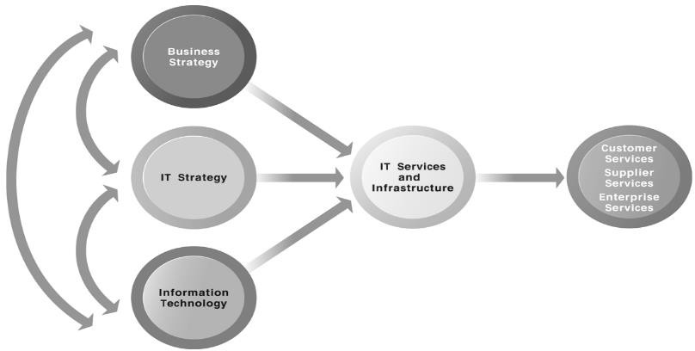
MIS
Infrastructure

Circle ‘Yes’ or ‘No’ where applicable for each item below:
1 | YES NO | The services a firm is capable of providing to its customers, suppliers,  and employees are a direct function of its MIS infrastructure.
2 | YES NO | The only service that will be affected by the quality of the MIS  infrastructure is the service provided to customers.
3 | YES NO | Ideally, this infrastructure should support the firm’s business and  information systems strategy.
4 | YES NO | This infrastructure should support the firm’s information systems  strategy, regardless of the business strategy.
5 | YES NO | The above illustration focusses more than anything else on the  relationship between Business Strategy and IT strategy.
6 | YES NO | The above illustration represents the centrality of MIS infrastructure  and services to the achievement of firm success.
7 | YES NO | Amazon is routinely sited as the most popular online shopping site. The main reason for this is that Amazon has been in this business more  than any other businesses.
8 | YES NO | Ultimately, what the firm delivers to customers, its quality, is a direct  function of the power of its infrastructure.
9 | YES NO | New information technologies have a powerful impact on business and  IT strategies, as well as the services that can be provided to customers.

QUESTION 2 (10 Marks)
A company is having difficulty preparing for future growth. The only information system used is an old accounting system mainly using spreadsheets. The company has one manufacturing plant located in Al- Ain; and three warehouses, in Al-Ain, Dubai, and Abu Dhabi. The sales force is national, and it purchases about a third of its parts and materials from a single overseas supplier. You have been hired to recommend the information systems it should implement in order to maintain its competitive edge. However, there is not enough money for a full-blown, cross-functional enterprise application, and you will need to limit the first step to a single functional area. Rank your choices of information systems, with justification, using a table as below to explain your order of choice/s.

Your order of Choice/s of Information Systems | Justification/s

QUESTION 3 (10 Marks- 5 each) - This question contains two sub questions a and b.
- Explain at least four main characteristics of Cloud Computing.
- Discuss at least two main drawbacks of Cloud computing, using examples where appropriate.

QUESTION 4 (10 Marks- 5 each)- This question contains two sub questions a and b.
- Define the term ‘database’? List 3 reasons why DBMS are better systems compared with flat files.
- Explain the importance of data mining tools and the types of information they produce. In what type of circumstance would you advise a company to use data mining?

QUESTION 5 (10 Marks- 5 each) - This question contains two sub questions a and b.
- A relative of yours approached you to provide some suggestions in improving the efficiency of a local sandwich shop. Firstly, describe at least three sandwich shop business processes. Can any of these processes be better coordinated through the use of information systems?

- Explain the three primary components of a comprehensive CRM system.

QUESTION 6 (10 Marks- 5 each)- This question contains two sub questions a and b.
Information ethics govern the ethical and moral issues arising from the development and use of information technologies, as well as the creation, collection, duplication, distribution, and processing of information itself (with or without the aid of computer technologies. Answer the following questions:
- Organizations should implement certain e-policies to protect themselves. Discuss.
- Authentication technologies that can be used to prevent hackers from gaining access to organizational systems. Discuss.

Part B:
Application & Case Study Questions
Answer ALL the following questions. You must read thoroughly the compiled article below, then answer ALL the following questions. You may also consult your study material and explore the Web where applicable/required. Follow the University’s guidelines for assignment referencing, formatting and structure. Mark for each question is given next to the question. Total mark for this section is 30.

Introduction to Information Systems

An information system is a set of interrelated components that work together to collect, process, store, and disseminate information to support decision making, coordination, control, analysis, and visualization in an organization. In addition to supporting decision making, information systems may also help managers and workers analyze problems, visualize complex subjects, and create new products. Wireless communications, including computers and mobile hand-held computing devices, are keeping managers, employees, customers, suppliers, and business partners connected in every way possible. Email, online conferencing, the web, and the Internet, are providing new and diverse lines of communication for all businesses, large and small. Through increased communication channels and decreased costs of the communications, customers are demanding more of businesses in terms of service and product, at lower costs. E-commerce is changing the way businesses must attract and respond to customers.

Information systems automate manual business processes and make an organization more efficient. Data and information are available to a wider range of decision-makers more quickly when information systems are used to change the flow of information. Tasks can be performed simultaneously rather than sequentially, speeding up the completion of business processes. Information systems can also drive new business models that perhaps wouldn’t be possible without the technology. The Internet and World Wide Web have had a tremendous impact on the role that information systems play in organizations. These two tools are responsible for the increased connectivity and collaboration within and outside the organization. The Internet, World Wide Web, and other technologies have led to the redesign and reshaping of organizations. They have helped transform the organization’s structure, scope of operations, reporting and control mechanisms, work practices, work flows, and products and services. Further, three information system trends that are influencing the way businesses interact with employees, customers, suppliers, and business partners include emerging mobile digital platforms, the growth of online software-as-a-service, and the growth of cloud computing.

Digital firm have many characteristics. Some of which are: Significant business relationships with customers, suppliers, and employees are digitally enabled and mediated. Core business processes are accomplished through digital networks spanning the entire organization or linking multiple organizations. Key corporate assets—intellectual property, core competencies, and financial and human assets—are managed through digital means. They sense and respond to their environments far more rapidly than traditional firms. They offer extraordinary opportunities for more flexible global organization and management, practicing time-shifting and space-shifting. Having said that, there are of course some challenges as well as opportunities of globalization. Customers no longer need to rely on local businesses for products and services. They can shop 24/7 for virtually anything and have it delivered to their door or desktop. Companies can operate 24/7 from any geographic location around the world. Jobs can just as easily move across the state or across the ocean. Employees must continually develop high-level skills through education and on-the-job experience that cannot be outsourced. Businesses must avoid markets for goods and serves that can be produced offshore much more cheaply. The emergence of the Internet into a full-blown international communications system has drastically reduced the costs of operating and transacting business on a global scale.

There are several strategic objectives of information systems that include: Operational excellence – businesses use information systems to improve efficiency and achieve higher profitability. New products, services, and business models – information systems allow companies to create new products and services and even new business models (example – online music streaming). Customer and supplier intimacy – information systems allow businesses to know their customers better, and customers respond by purchasing more. Improved decision making – information systems allow companies to make better decisions using better information. Competitive advantage – information systems help companies outperform their competitors. Survival – information systems are necessities for doing business, and companies could not survive without them.

QUESTIONS (5 marks each)

Identify three major new information system trends. Explain how the Internet and the World Wide Web are related to the other technology components of information systems.

- Describe how information systems have changed the way businesses operate and their products and services.

- Describe the challenges and opportunities of globalization in a “flattened” world.

- List and briefly describe the six strategic business objectives of information systems.

- United Parcel Service Inc. (UPS), is a global company with one of the most recognised and admired brands in the world, using information systems, access to global resources, and an integrated network of physical, technological, and human assets. Apply Porter’s Five Forces analytical framework to UPS. Your answer should include critical elements and supported with evidence/ justification.

- Discuss UPS embracement of sustainable technologies and the benefits of doing so

